SOFTWARE TESTING LABORATORY MANUAL
Experiment 4

Experiment 4: Code Quality Scan using SonarLint (Java/Python)
Aim: To perform a static code quality scan on a small Java or Python project using the SonarLint IDE plugin and fix the reported issues.
Software / Tools Required: VS Code, SonarLint plugin, Python 3 installed

Theory
SonarLint is a free IDE extension that performs static code analysis as you type, flagging Bugs, Vulnerabilities, Code Smells, and Security Hotspots against a rule set (Sonar way). Unlike compiler errors, these issues do not stop the program from running — they highlight maintainability and reliability risks such as unused variables, duplicate code, empty catch blocks, or hard-coded credentials.

Sample Code with Intentional Issues (Python)

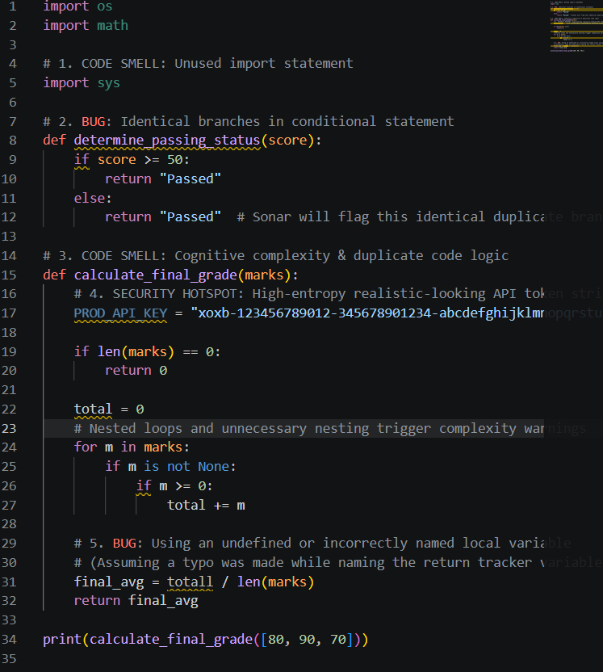

Procedure
- Install VS Code and add the ‘SonarLint’ extension from the marketplace.
- Open the sample project folder containing py file
- SonarLint automatically analyses the file on save; issues appear as underlines in the editor and in the ‘Problems’/‘SonarLint’ panel.
- Open the SonarLint panel and note each issue's rule, severity, and description.
- Re-run the scan and confirm the issue count drops to zero.

Sample Findings Table
Line | Type | Severity | Issue | Fix Applied
6 | Bug | Blocker | Possible division by zero | Added check: if not marks: return 0
10 | Security Hotspot | Critical | Hard-coded password | Removed unused password variable
18 | Code Smell | Minor | Unused variable 'unused_var' | Deleted the line

